Core|Sub Status: Change Process Title

Contents
Document Version Control 1
Approved process for raising 2
Consultation & Approval 2
Change Management 2
How to 3
Testing 4
Communications 4
Downstream Systems & Processes 4
Affected Reports 4
Additional Background Information 4

Document Version Control
Change History/Review Details
Date | Version | Review by | Summary of Change
22/11/21 | 1.0 | Simon Burford | Initial document capturing lessons from the introduction of the ZP80 sub category.

Approved process for raising
Does the change need to be raised through a particular route or by a particular person/team? Are there any actions which need to be taken or considered prior to processing in the HRIS Support Centre?

Consultation & Approval
Who is the owner of this information? Who needs to be consulted about this change before you begin work on it? Does anyone need to approve this change before it is implemented?
Employee Sub Statuses should normally be driven by the HESA list of Sub Statuses. It is very rare, other than for system limitation reasons, that a different Sub Status would be created, so all new Sub Status requests should be approved by the HR Analytics team who manage the staff HESA return.

Change Management
What type of change is this? When should approval be sought and from whom (internal to team or change manager)? Who would normally be responsible for implementing?

How to
Technically how to process the change in the system
Adding a new ….
Navigate to:

Changing a ….
Navigate to:

Removing a ….
Navigate to:

Standard Icons & Terminology
Standard Button Names  Enter Query Mode button:  Previous Record button:   Previous Section button:   Save button:   Insert Record button:  | Execute Query button:   Next Record button:   Next Section button:   LOV button:   Delete Record button:  | Cancel Query button:   Red Door button:   Duplicate Record button: 
Navigation Paths

Show the final navigation path option in bold+italics, for example;

Core|Personnel > Reference > Reference A – C > Accident Codes
Core|Pay > Reference > Pay Groups

Any further navigation beyond the navigation path can be added after an ellipsis (…), for example;

Event Management > Event Configuration … HR Events > Change of Address

Other Standard Terminology

Testing
Who would normally be responsible for testing? Are there standard items to test?

Communications
Who needs to be informed (but not consulted) about this change? Detail when they should be informed (before or after the change).
Interfaces
The Sub Category is used in interfaces, if any code is created which is not a standard 2 digit length then the IAM systems team (currently Stu Mozley) will need to be advised as they have a feed which looks for the list of sub category codes.

Downstream Systems & Processes
Details of any processes which are affected or need to be carried out following, or as part of, the change. Please detail any triggers, actions required and when the actions should be carried out.
General Ledger
Any new Sub Statuses will have an affect on the GL matrix. The Expense Code on some GL files will be derived from the combination of Sub Status and Payment Analysis Code. Any new Sub Status code is likely to need to have the associated Expense Code mapped against each Payment Analysis Type within the Profile and Loss GL Matrix: 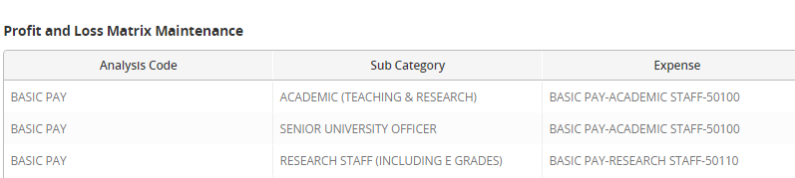
Please see the “Mandatory Field” section of the “Additional Background Information” for details of exceptions to this.

Affected Reports
Are there any standard reports which may need to be updated following this change?

Additional Background Information
Any other relevant information, links to supporting documentation etc.
Mandatory Field
The Sub Category Field is a mandatory field on Core and the use of the existing fields is mapped to expense codes in the GL matrix. We have needed to set up an additional Sub Category; ZP80 – DO NOT USE PAY GROUP 80 ONLY to allow the Pensioner Payroll administrators to set up pensioner records, if existing Sub Categories were used the pensioner GL would map their payments to the wrong expense code, however the expense code should be driven by the pay code for these employees. We have set up the new sub category and purposefully not included it in the P&L matrix so that the system will derive the expense code from the Pay Code instead of the P&L matrix.

